Q1.

<html>

<head>

    <link rel="stylesheet" href="html&cssassignmentQ1.css">

    <title>Virat Kohli</title>

</head>

<body>

    <h1>A Tribute To "The Run Machine"</h1>

    <p id="main">Virat Kohli is a 33-year old right-handed batsman in Indian Team.

        He has been the captain of Indian side in all 3-formats of the game. </p>

    <div>

        <img class="virat" src="img/virat.jpg">

    </div>

    <div>

        <p>

            Today I’ll be mentioning the hardworking and determined life of one the greatest player of Indian Team Virat

            ‘THE RUN MACHINE’ Kohli. Yeah! You are right, I’ll be writing Virat Kohli Biography. Virat Kohli, who is he?

            Does he belongs to a big, rich or well known family? A big NO. Virat Kohli is a 29-year old right-handed

            batsman

            in Indian Team. He is now the captain of Indian side in all 3-formats of the game. He has been absolutely

            brilliant in his game.

        </p>

        <p>

            I’ll be telling you about his supportive family too. Virat Kohli had been exceptionally well from st few

            years.

            His advertising value is increasing day-by-day. Lets start with the Biography of THE VIRAT KOHLI – THE RUN

            MACHINE.

        </p>

    </div>

    <div>

        <h2>Milestones reached by Virat Kohli</h2>

        <ul>

            <li>Fastest Indian to reach 1000, 5000, 6000, 7000, 8000, 9000, and 10,000 runs in ODIs</li>

            <li>Fastest Indian and second fastest in the world to reach 10, 15, 20, and 25 centuries in ODIs</li>

            <li>The only batsman in history to average more than 50 in Tests, ODIs, and T20Is simultaneously</li>

            <li>Fastest in the world to reach 30 and 35 centuries in ODIs</li>

            <li>Second fastest in the world to reach 1,000 runs in T20Is</li>

            <li>First Indian cricketer to score three successive centuries in ODIs</li>

            <li>Fastest in the world to reach 15,000 international runs</li>

            <li>Fastest batsman to score 17,000 runs in international cricket (363 innings)</li>

            <li>First batsman to reach 6000 runs in IPL tournament</li>

            <li>Virat Kohli holds the record for the fewest innings(462 innings) to reach 22000 International runs

                followed by Sachin Tendulkar who took 493 innings to achieve this feat.</li>

            <li>Kohli scored 23000 runs from playing 490 international matches with a 50+ average – the only player to

                score 20000+ runs with a 50+ average.</li>

            <li>Virat Kohli becomes the first Indian cricketer to cross 10,000 T20 runs.</li>

        </ul>

    </div>

    <div>

        <p id="thanks">Thank you <strong>Virat Kohli!!</strong></p>

    </div>

</body>

</html>

Style.css

body{

    background: #faeae6;

    padding: 120px;

}

h1 {

    font-family: Arial, Helvetica, sans-serif;

    font-size: 40px;

    color: rgb(39, 97, 155);

    background-color: rgb(245, 241, 237);

    text-align: center;

}

#main{

    font-size: 20px;

    color: rgb(9, 61, 61);

    text-align: center;

}

.virat{

    width: 100%;

    text-align: center;

}

p{

    font-family: Arial, Helvetica, sans-serif;

    color: rgb(9, 61, 61);

    text-align: justify;

}

h2{

    font-family: Arial, Helvetica, sans-serif;

    font-size: 30px;

    color: crimson;

    text-align: center;

    background: beige;

}

ul{

    font-size: 18px;

    color: rgb(9, 61, 61);

    text-align: justify;

    font-family: Arial, Helvetica, sans-serif;

}

#thanks{

    font-size: 30px;

    font-family: Arial, Helvetica, sans-serif;

    color: crimson;

    text-align: center;

}

#thanks strong{

    color: rgb(150, 10, 38);

}

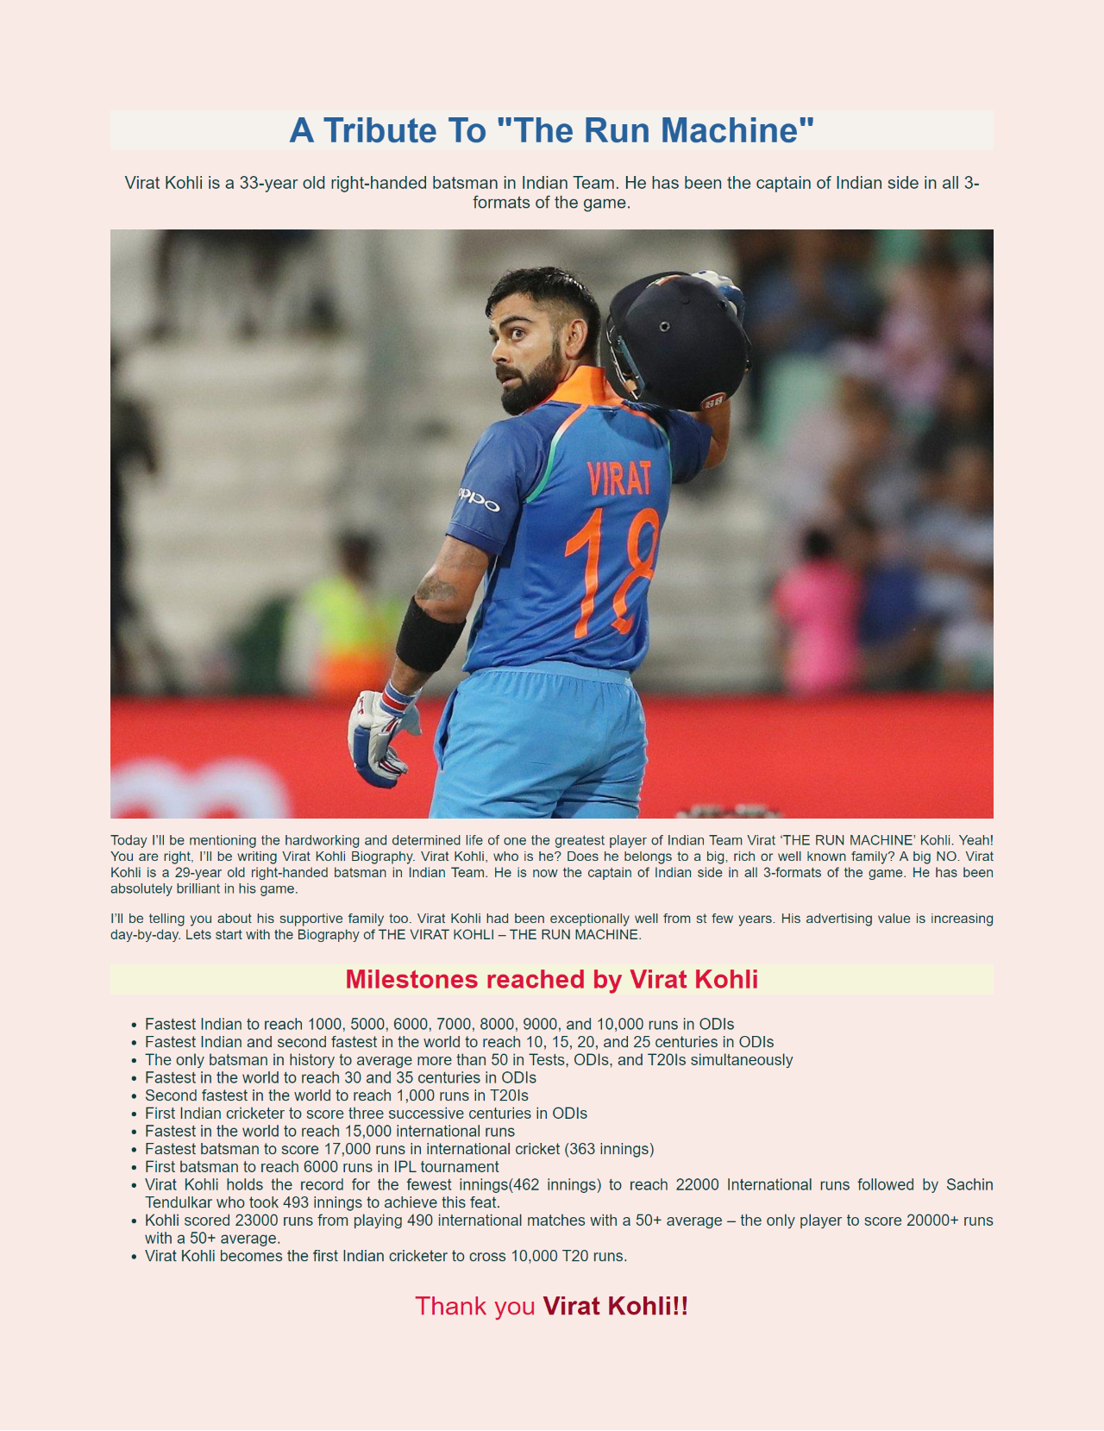

Q2.

body {

    font-family: Arial, Helvetica, sans-serif;

}

form {

    border: 3px solid cadetblue;

    width: 300px;

    padding: 40px;

}

h1 {

    font-size: 40px;

    color: crimson;

}

label{

    font-size: 20px;

    color: lightslategray;

}

p{

    font-size: 20px;

    color: lightslategray;

}

input{

    width: 300px;

    margin: 8px 0;

    display: inline-block;

    box-sizing: border-box;

    padding: 20px;

    border-color: darkseagreen;

}

div{

    width: 600px;

}

.radio input{

    text-align: center;

    width: 50px;

}

<html>

    <head>

        <link rel="stylesheet" href="html&cssassignmentQ2.css">

        <title>Login Form</title>

    </head>

    <body>

        <h1>LOGIN FORM</h1>

        <form>

            <div>

                <input type="text" name="name" placeholder="NAME"><br><br>

                <input type="text" name="education" id="education" placeholder="Education"><br><br>

                <input type="text" name="age" id="age" placeholder="Age"><br><br>

            </div>

            <div class="radio">

                <p>Your gender: </p>

                <input type="radio" name="gender" id="gender">

                <label for="male">Male</label><br>

                <input type="radio" name="gender" id="gender">

                <label for="female">Female</label><br>

                <input type="radio" name="gender" id="gender">

                <label for="not"> Prefer not to specify</label><br><br><br>

                <input type="checkbox" name="married" id="married">

                <label for="married">Are you married</label><br><br>

            </div>

            <div>

                <input type="button" name="submit" id="submit" value="Register">

            </div>

        </form>

    </body>

</html>

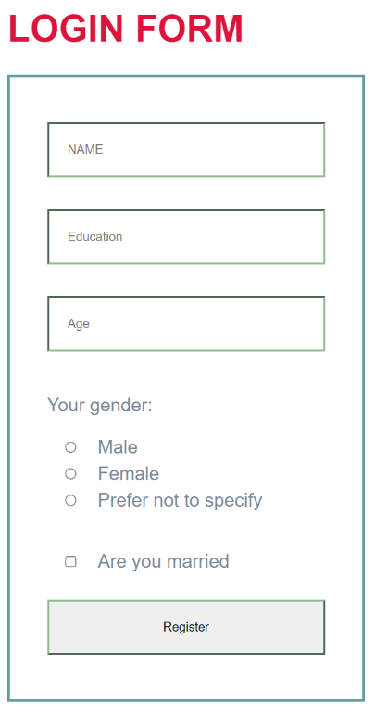

Q3. Showcase your solid knowledge of HTML and CSS creating a beautiful webpage for a restaurant. Making a layout for a restaurant will be a bit complicated than previous project examples. You will be aligning the different food items and drinks using a CSS layout grid. You will be adding prices, images and you need to give it a beautiful look and feel as well using the proper combination of colors, font-style and images. You can add pictures gallery for different food items, you can also add sliding images for a better look. Add links for redirection to internal pages. Make it responsive setting a viewport, using media queries and grid. You can take help from [**Restaurant Website**](https://jolly-kalam-23776e.netlify.com/restaurantwebsite/).

<!DOCTYPE html>

<html lang="en">

<head>

    <meta charset="UTF-8">

    <meta http-equiv="X-UA-Compatible" content="IE=edge">

    <meta name="viewport" content="width=device-width, initial-scale=1.0">

    <link rel="stylesheet" href="html&cssassignmentQ3.css">

    <title>Assignment 3</title>

</head>

<body>

    <div class="wrapper">

        <nav class="menu">

            <ul class="menu-list">

                <li class="l1">

                    <a href="">Starter</a>

                </li>

                <li class="l2">

                    <a href=""> Soft Drinks</a>

                </li>

                <li class="l3">

                    <a href="">Hard Drinks</a>

                </li>

                <li class="l4">

                    <a href="">Desserts</a>

                </li>

                <li class="l5">

                    <a href="">Resservations</a>

                </li>

            </ul>

        </nav>

        <div class="top">

            <header class="hero">

                <h1>Vemzies</h1>

                <p>Pretty Good Food!</p>

            </header>

            <div class="cta cta1">

                <p class="price">Rs.350</p>

                <p>Soft Sizlers</p>

            </div>

            <div class="cta cta2">

                <p class="price">Rs.550</p>

                <p>Sexy Noodles</p>

            </div>

        </div>

        <section class="features">

            <div class="feature">

                <h3>Noodles</h3>

                <p>Noodle, a cooked egg-and-flour paste prominent in European and Asian cuisine, generally distinguished

                    from pasta by its elongated ribbonlike form. Noodles are commonly used to add body and flavour to

                    broth soups.</p>

            </div>

            <div class="feature">

                <h3>Soft Drinks</h3>

                <p> Any of a class of nonalcoholic beverages, usually but not necessarily carbonated, normally

                    containing a natural or artificial sweetening agent, edible acids, natural or artificial flavours,

                    and sometimes juice. </p>

            </div>

            <div class="feature">

                <h3>Hard Drinks</h3>

                <p> hard drink - an alcoholic beverage that is distilled rather than fermented. booze, hard liquor, John

                    Barleycorn, liquor, spirits, strong drink. alcohol, alcoholic beverage, alcoholic drink, inebriant,

                    intoxicant - a liquor or brew containing alcohol as the active agent; "alcohol (or drink) ruined

                    him"</p>

            </div>

            <div class="feature">

                <h3>Exotic Music</h3>

                <p>Lorem ipsum, dolor sit amet consectetur adipisicing elit. Eligendi non, asperiores hic recusandae

                    facere optio est molestiae ratione vitae ullam. Aut magnam cumque recusandae quia voluptate, iure ut

                    ea corporis illo quam in animi, quas dignissimos commodi tenetur explicabo mollitia consequatur

                    adipisci corrupti. Architecto consectetur beatae cupiditate reiciendis ad dignissimos?</p>

            </div>

        </section>

        <section class="about">

            <img src="img1/noodles.jpg" alt="" class="about__noodles">

            <h2>Featured Sexy Noodles</h2>

            <p>Slim Profile, easy to hold and loaded with cheese.</p>

            <p>This is the one you have been waiting for</p>

            <button>Learn More-></button>

        </section>

        <section class="gallery">

            <h2>Insights of Vemzies</h2>

            <img src="img1/burger.jpg" alt="">

            <img src="img1/chef.jpg" alt="">

            <img src="img1/drinks.jpg" alt="">

            <img src="img1/seating.jpg" alt="">

            <img src="img1/table.jpg" alt="">

        </section>

    </div>

</body>

</html>

body {

    font-size: 15px;

}

button {

    background: #ffc600;

    border: 0;

    padding: 10px 20px;

}

img {

    max-width: 100%;

}

/* .wrapper */

.wrapper {

    display: grid;

    grid-gap: 20px;

}

.top {

    display: grid;

    grid-gap: 20px;

    grid-template-areas:

        "hero hero cta1"

        "hero hero cta2"

}

.hero {

    grid-area: hero;

    min-height: 400px;

    background: white url(img1/noodles.jpg);

    background-size: cover;

    background-position: bottom right;

    padding: 50px;

    display: flex;

    flex-direction: column;

    align-items: start;

    justify-content: center;

}

.hero>* {

    background: var(--yellow);

    padding: 5px;

}

.cta {

    background: var(--yellow);

    display: grid;

    align-items: center;

    justify-items: center;

    align-content: center;

}

.cta p {

    margin: 0;

}

.cta1 {

    grid-area: cta1;

}

.cta2 {

    grid-area: cta2;

}

.price {

    font-size: 60px;

    font-weight: 300;

}

/* Navigation */

.menu ul {

    display: grid;

    grid-gap: 10px;

    padding: 0;

    list-style: none;

    grid-template-columns: repeat(auto-fit, minmax(100px, 1fr));

}

.menu a {

    background: var(--yellow);

    display: block;

    text-decoration: none;

    padding: 10px;

    text-align: center;

    color: var(--black);

    text-transform: uppercase;

    font-size: 20px;

}

[aria-controls="menu-list"] {

    display: none;

}

/* Features! */

.features {

    display: grid;

    grid-gap: 20px;

    grid-template-columns: repeat(auto-fit, minmax(200px, 1fr));

}

.feature {

    background: white;

    padding: 10px;

    border: 1px solid white;

    text-align: center;

    box-shadow: 0 0 4px rgba(0, 0, 0, 0.1);

}

.feature .icon {

    font-size: 50px;

}

.feature p {

    color: rgba(0, 0, 0, 0.5);

}

/* About Section */

.about {

    background: white;

    padding: 50px;

    display: grid;

    grid-template-columns: 400px 1fr;

    align-items: center;

}

/* Gallery! */

.gallery {

    display: grid;

    grid-gap: 20px;

    grid-template-columns: repeat(auto-fit, minmax(200px, 1fr));

}

.gallery img {

    width: 100%;

}

.gallery h2 {

    color: #f93d66;

    grid-column: 1 / -1;

    display: grid;

    grid-template-columns: 1fr auto 1fr;

    grid-gap: 20px;

    align-items: center;

}

.gallery h2:before, .gallery h2:after {

    display: block;

    content: '';

    height: 10px;

    background: linear-gradient(to var(--direction, left), var(--yellow), transparent);

}

.gallery h2:after {

    --direction: right;

}

@media (max-width: 1000px) {

    .menu {

        perspective: 800px;

    }

    [aria-controls="menu-list"] {

        display: block;

        margin-bottom: 10px;

    }

    .menu ul {

        max-height: 0;

        overflow: hidden;

        transform: rotateX(90deg);

        transition: all 0.5s;

    }

    [aria-expanded="true"]~ul {

        display: grid;

        max-height: 500px;

        transform: rotateX(0);

    }

    [aria-expanded="false"] .close {

        display: none;

    }

    [aria-expanded="true"] .close {

        display: inline-block;

    }

    [aria-expanded="true"] .open {

        display: none;

    }

}

@media (max-width: 700px) {

    .top {

        grid-template-areas:

            "hero hero"

            "cta1 cta2"

    }

    /* About */

    .about {

        grid-template-columns: 1fr;

    }

}

@media (max-width: 500px) {

    .top {

        grid-template-areas:

            "hero"

            "cta1"

            "cta2"

    }

}

/*

  Oh Hello!

  These are some base styles so that our tutorial looks good.

  Let's go through the important bits real quick

*/

:root {

    --yellow: #ffc600;

    --black: #272727;

}

html {

    /* border-box box model allows us to add padding and border to our elements without increasing their size */

    box-sizing: border-box;

    /* A system font stack so things load nice and quick! */

    font-family: Arial, Helvetica, sans-serif;

    font-weight: 900;

    font-size: 10px;

    color: var(--black);

    text-shadow: 0 2px 0 rgba(0, 0, 0, 0.07);

}

/*

    WAT IS THIS?!

    We inherit box-sizing: border-box; from our <html> selector

    Apparently this is a bit better than applying box-sizing: border-box; directly to the * selector

  */

*,

*:before,

*:after {

    box-sizing: inherit;

}

body {

    background-image: url("img1/bulb.jpeg"),

        linear-gradient(110deg, #f93d66, #6d47d9);

    background-size: 340px, auto;

    min-height: calc(100vh - 100px);

    margin: 50px;

    /* background: white; */

    background-attachment: fixed;

    letter-spacing: -1px;

}

h1,

h2,

h3,

h4,

h5,

h6 {

    margin: 0 0 5px 0;

}

/* Each item in our grid will contain numbers */

.item {

    /* We center the contents of these items. You can also do this with flexbox too! */

    display: grid;

    justify-content: center;

    align-items: center;

    border: 5px solid rgba(0, 0, 0, 0.03);

    border-radius: 3px;

    font-size: 35px;

    background-color: var(--yellow);

    /* best colour */

}

.item p {

    margin: 0 0 5px 0;

}

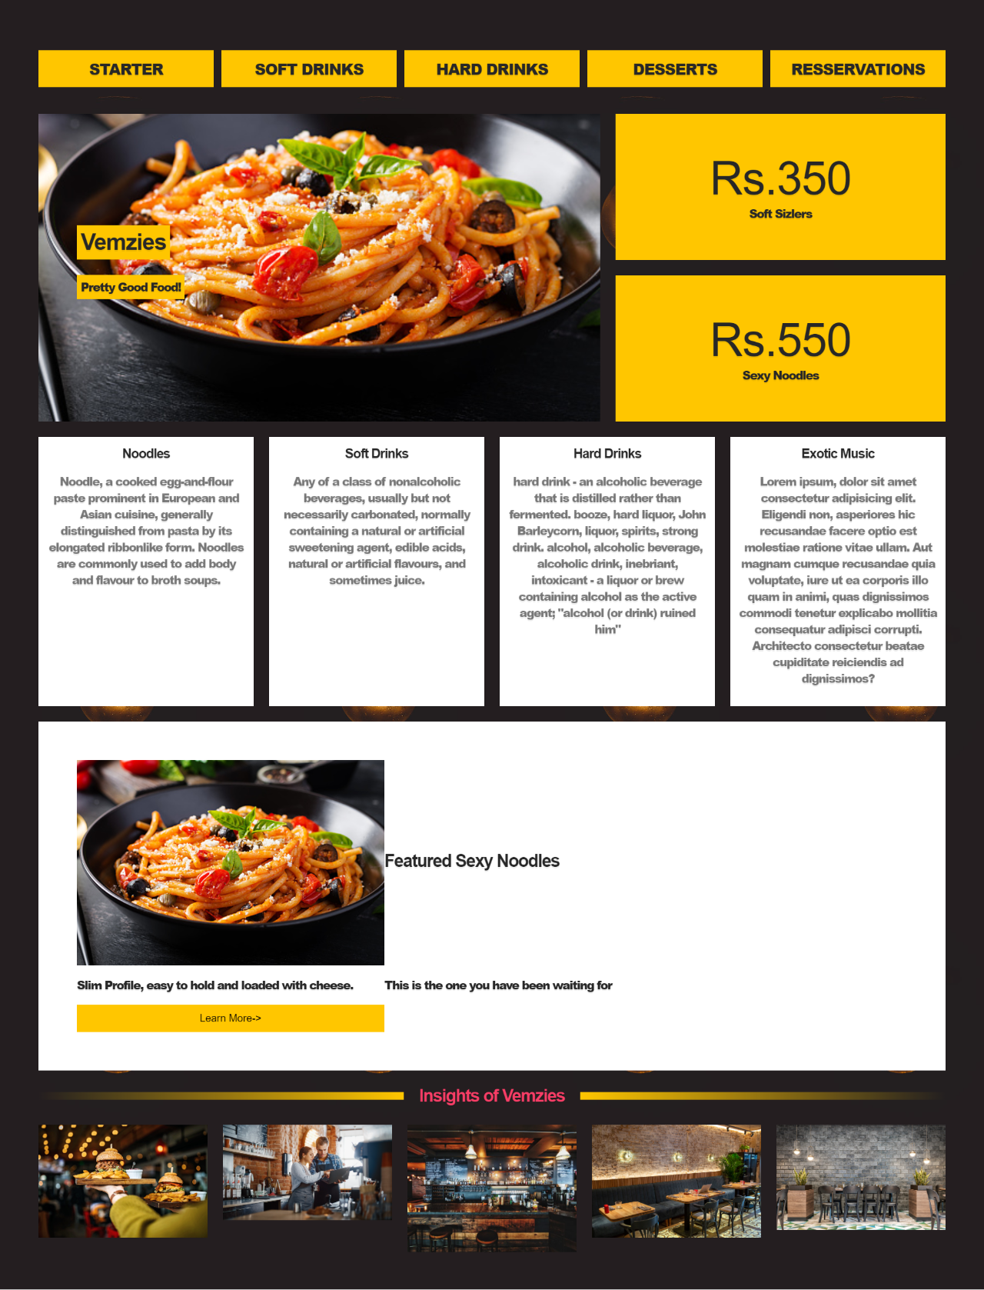

Q4.

If you are a music lover you can make a webpage for it. It requires HTML5/[CSS3](https://www.geeksforgeeks.org/advantage-of-css3-over-css/)knowledge. Add a suitable background image describing the purpose or what the page is all about. In the header section add different menus. Add buttons, links, images and some description about the collection of songs available. At the bottom mention the links for shopping, store, career or contact details. You can also add other features on your webpages such as a trial option, gift cards or subscription. Make it responsive setting viewport or using media queries and grid. You can take help from the [**myTunes**](https://jolly-kalam-23776e.netlify.com/mytunes/).

<!DOCTYPE html>

<html lang="en">

<head>

    <meta charset="UTF-8">

    <meta http-equiv="X-UA-Compatible" content="IE=edge">

    <meta name="viewport" content="width=device-width, initial-scale=1.0">

    <link rel="stylesheet" href="html&cssassignmentQ4.css">

    <title>Assignment 4</title>

</head>

<body>

    <div class="showcase">

        <header>

            <nav class="nav">

                <ul class="cf">

                    <li class="hide-on-small">

                        <a href="#showcase">myTunes</a>

                    </li>

                    <li>

                        <a href='#showcase'>Overview</a>

                    </li>

                    <li>

                        <a href='#music'>Music</a>

                    </li>

                    <li>

                        <a href='#video'>Video</a>

                    </li>

                    <li>

                        <a href='#gift-cards'>Gift Cards</a>

                    </li>

                </ul>

            </nav>

        </header>

        <div class="section-main container">

            <h2>We put the mental in instrumental and the cool in musicool</h2>

            <h1>Vemzies Musicool</h1>

            <p class="lead hide-on-small">

                Vemzies is the best way to organize and enjoy the music, movies, and TV shows you already have — and

                shop for the ones you want. Enjoy all the entertainment Vemzies has to offer on your Mac and PC.

            </p>

        </div>

    </div>

    <!-- Music Section -->

    <section id="music" class="section">

        <div class="container">

            <h2 class="section-head">

                <i class="fas fa-music"></i> Music

            </h2>

            <h3>1 million songs. Zero ads.</h3>

            <p class="lead">Stream over 1 million songs, ad-free.

                Or download albums and tracks to listen to offline.

                All the music in your personal

                Vemzies library — no matter where it came from — lives

                right alongside the Orange Music catalog. Start your free

                three-month trial with no commitment, and cancel anytime.</p>

            <a href="#" class="btn btn-primary mb">Start Your Trial Now</a>

            <p class="text-light">Orange Music is available in Vemzies, and for iOS and Android devices.</p>

            <img class="img1" src="img2/music.jpeg" alt="">

            <br>

            <br>

            <br>

        </div>

    </section>

    <!-- Gift Card Section -->

    <section id="gift-cards" class="section bg-light">

        <div class="container">

            <div class="gift-cards">

                <div>

                    <img class="img2" src="img2/giftcard.jpeg" alt="">

                </div>

                <div>

                    <h2>Gift Cards</h2>

                    <p>

                        Lorem ipsum dolor, sit amet consectetur adipisicing elit. Neque expedita tempore quasi omnis a

                        aut

                        et totam illo fuga accusamus

                        dolorum vero, ut harum consectetur. Minima molestias officiis culpa non sed dicta itaque. Et

                        aliquam illo obcaecati

                        molestias veritatis porro.

                    </p>

                    <p>Already have an Orange MyTunes Music Gift Card?</p>

                    <hr>

                    <a href="#" class="text-secondary">

                        <i class="fas fa-chevron-right"></i> Redeem

                    </a>

                </div>

            </div>

        </div>

    </section>

    <!-- Footer -->

    <footer>

        <div class="container">

            <div class="footer-cols">

                <ul>

                    <li>Shop & Learn</li>

                    <li>

                        <a href="#">Music</a>

                    </li>

                    <li>

                        <a href="#">Movies</a>

                    </li>

                    <li>

                        <a href="#">Shows</a>

                    </li>

                    <li>

                        <a href="#">Apps</a>

                    </li>

                    <li>

                        <a href="#">Gift Cards</a>

                    </li>

                </ul>

            </div>

        </div>

        <div class="footer-bottom text-center">

            Copyright &copy; 2022 Vemzies Musicool

        </div>

    </footer>

</body>

</html>

body {

    font-family: 'Segoe UI', Tahoma, Geneva, Verdana, sans-serif;

    background-color: #11111d;

    margin: 0%;

    color: white;

    line-height: 1.6;

    text-align: center;

}

.showcase h1 {

    font-size: 4rem;

    margin-bottom: 0%;

}

h1 {

    display: block;

    font-size: 2em;

    margin-block-start: 0.67em;

    margin-block-end: 0.67em;

    margin-inline-start: 0px;

    margin-inline-end: 0px;

    font-weight: bold;

}

a {

    color: white;

}

.section .container .img1 {

    image-rendering: optimizeQuality;

}

.showcase {

    background-image: url(./img2/musicool1.jpg);

    width: 100%;

    height: 100vh;

    position: relative;

    background-size: cover;

    overflow-y: hidden;

}

.showcase .container {

    margin-top: 25vh;

}

.showcase h1 {

    font-size: 4rem;

    color: rgb(245, 245, 153);

}

.showcase h2 {

    font-size: 2rem;

    color: rgb(245, 245, 153);

}

nav {

    height: 40px;

    width: 100%;

    background-color: #333;

    color: rgb(51, 34, 34);

    position: fixed;

}

nav ul {

    padding: 0;

    margin: 0;

}

nav li {

    display: inline;

    float: left;

}

nav a {

    display: inline-block;

    width: 100px;

    text-align: center;

    text-decoration: none;

    padding: 10px 0;

    color: #eee;

    text-decoration: none;

}

nav li:hover {

    background-color: #444;

}

nav a#openup {

    display: none;

}

#music {

    background-color: darkolivegreen;

}

.btn {

    padding: 1rem;

    text-decoration: none;

    color: black;

    display: inline-block;

}

.btn-primary {

    background: rgb(253, 239, 39);

}

.gift-cards {

    display: grid;

    background-color: #eee;

    color: #11111d;

    grid-gap: 20px;

    grid-template-columns: repeat(2, 1fr);

    text-align: left;

}

.gift-cards .img2 {

    width: 100%;

    height: 400px;

}

/* Footer */

footer .footer-cols {

    display: grid;

    grid-gap: 20px;

    grid-template-columns: repeat(4, 1fr);

    padding: 2rem;

    text-align: left;

    font-size: 14px;

}

footer .footer-cols ul {

    list-style: none;

}

footer .footer-cols ul li:first-child {

    font-size: 1.2rem;

    padding-bottom: 0.5rem;

    border-bottom: #444 solid 1px;

    margin-bottom: 1rem;

}

footer .footer-bottom {

    background: #333;

    padding: 1rem;

}

@media screen and (max-width: 580px) {

    .hide-on-small {

        display: none;

    }

    #showcase {

        height: 50vh;

    }

    #showcase .container {

        margin-top: 15vh;

    }

    #showcase h1 {

        font-size: 3rem;

    }

    #showcase h2 {

        font-size: 1.5rem;

    }

    nav {

        height: auto;

        border-bottom: 0;

    }

    nav ul {

        display: none;

        height: auto;

    }

    nav li {

        width: 100%;

        float: left;

        position: relative;

    }

    nav a {

        text-align: left;

        width: 100%;

        text-indent: 25px;

        background: #333;

        border-bottom: 1px solid #555;

    }

    nav a:hover {

        background: #444;

    }

    nav a#openup:after {

        content: "|||";

        transform: rotate(-90deg);

        -ms-transform: rotate(-90deg);

        /* IE 9 */

        -webkit-transform: rotate(-90deg);

        /* Safari and Chrome */

        width: 30px;

        height: 30px;

        display: inline-block;

        position: absolute;

        right: 5px;

        top: 20px;

    }

    nav a#openup {

        display: block;

        background-color: #333;

        width: 100%;

        position: relative;

    }

}

